**Car Pool**

**Brief:**

The responsive web portal aims to provide listing of all vehicles going from and to campus. The scope of app includes booking of seats in the vehicles on first come first serve basis and viewing the seats booked.

This document describes the various cases of the app. Use Case Diagram:

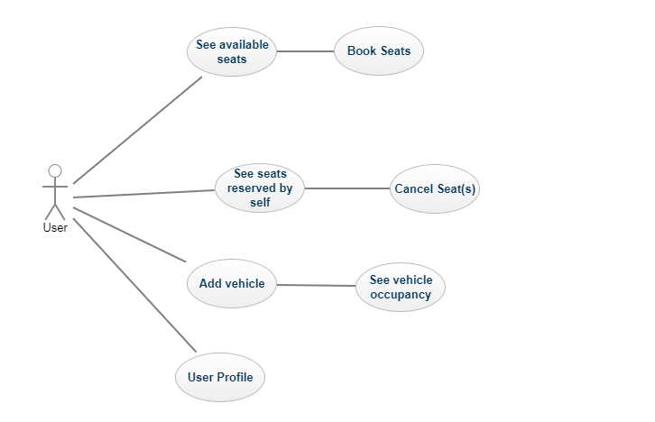

Figure 1.1

**1.** **See Available seats**:

After getting authorized with Ashoka’s email ID, user is welcomed with list of all vehicles leaving campus, parker and Jahangirpuri. The list by default contains all vehicles leaving with 3 hours from present time on present date. User have controls to see list of all vehicles leaving on a particular date of user’s choice. Giving priority to Shuttle, all the vehicles appear after shuttle for a particular date and time. Only vehicles with available seats are shown.

Wireframe: see available seats _ book seats.png | see bookings.png

**2. Book Seats:**

On the ‘see available seats’ view, each vehicle have button allowing user to book seat in that particular vehicle. There is no maximum cap for booking seat in any vehicle as long as seat is available (To allow booking seats for relatives). The colour of add button changes when a seat is booked in a particular vehicle.

Wireframe: see available seats _ book seats.png

**3. See seats reserved by self:**

Main menu contains the link to see list of all reserved bookings made by a user corresponding to the logged in ID. This list contains details like date, time, vehicle, contact details of the person who posted the vehicle for carpool.

Wireframe: see bookings _ cancel bookings.png

**4. Cancel seats:**

The ‘See seats reserved by self’ menu contains cancel button in front of each vehicle allowing user to cancel the reserved seat in a particular vehicle. After cancellation is made, the vehicle is again listed under ‘See available seats’ as having available seats.

Wireframe: see bookings _ cancel bookings.png

**5. Add vehicle:**

User is allowed to add details of vehicles for carpool. Details may include departing time, number of seats available (available occupancy), destination to be dropped at (parker, Jahangirpuri) and charge per seat, in case user wants to charge. All transactions are to be made in-person, portal does not having any provision except indicating the charges.

Wireframe: add vehicle.png

**6. See Vehicle Occupancy:**

User can see all the vehicles he/she has listed for carpool along with the details of users who have reserved seats. This menu is indicative of number of seats reserved/available.

Wireframe: see my vehicles.png

**7. User Profile:**

Every user after authorization using Ashoka’s email ID, needs to fill in the contact details. These details will be available to people who book seats under carpool added by a particular user. Also, person pooling his/her vehicle would be able to see this detail for all the occupants.

Wireframe: user profile.png

Attached with this document are wireframes along with the HTML coded front page indicative of listing page. HTML page is only an indication and not the final product.